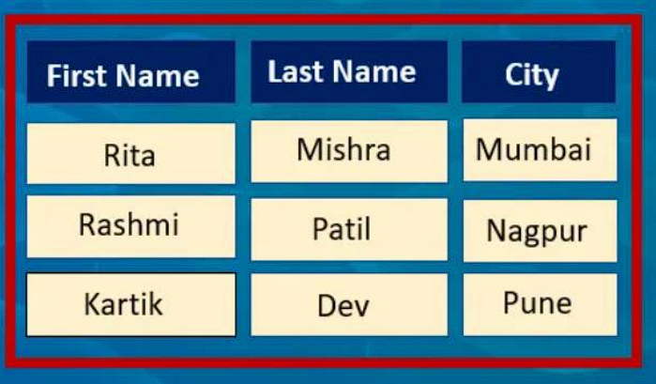
HTML Code
HTML Code
<!DOCTYPE html>
<html lang="en">
<head>
<meta charset="UTF-8">
<meta name="viewport" content="width=device-width, initial-scale=1.0">
<title>Styled Table</title>
<link rel="stylesheet" href="styles.css">
</head>
<body>
<div class="table-container">
<table>
<tr>
<th>First Name</th>
<th>Last Name</th>
<th>City</th>
</tr>
<tr>
<td>Rita</td>
<td>Mishra</td>
<td>Mumbai</td>
</tr>
<tr>
<td>Rashmi</td>
<td>Patil</td>
<td>Nagpur</td>
</tr>
<tr>
<td>Kartik</td>
<td>Dev</td>
<td>Pune</td>
</tr>
</table>
</div>
</body>
</html>

CSS code:
body {
font-family: Arial, sans-serif;
background-color: #008CBA; /* Background color similar to the image */
display: flex;
justify-content: center;
align-items: center;
height: 100vh;
margin: 0;
}

.table-container {
border: 5px solid red; /* Outer red border */
padding: 10px;
background-color: #002f6c; /* Dark blue background */
}

table {
width: 100%;
border-spacing: 0; /* No spacing between cells */
text-align: center;
background-color: #fff0e0; /* Light yellow color for cells */
border: 2px solid red; /* Border for the entire table */
}

th, td {
padding: 10px;
border: 2px solid #002f6c; /* Border between cells */
}

th {
background-color: #1660c1; /* Dark blue for header */
color: white;
}

